National Student Transfer Week 2024 at UNM
Instagram Guide

This is a posting guide for those who’d like to spread the word about the various events happening on UNM’s National Student Transfer Week, October 21 – 25, 2024!

Please use the hashtags: #transferstudentweek #iamalobo #transferproud

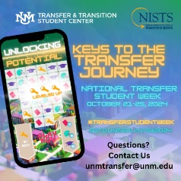Week Overview of NTSW Events / Save the Date!
Suggested caption: Celebrate UNM National Transfer Student Week! Check back for events throughout the week #transferstudentweek #iamalobo #transferproud

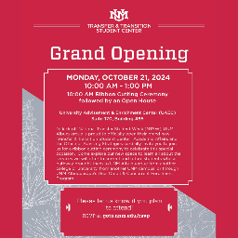Monday, October 21, 2024, from 10am - 2pm
Suggested caption: To kick off UNM's National Transfer Student Week, attend the Ribbon Cutting Ceremony & Open House for UNM’s New Transfer & Transition Student Center! #transferstudentweek #iamalobo #transferproud

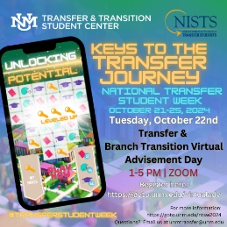Tuesday, October 22, 2024, from 1:00pm - 5:00pm
Suggested caption: UNM Transfer & Branch Transition Virtual Advisement Day. Visit here to schedule an advising appointment: goto.unm.edu/virtualadv
#transferstudentweek #iamalobo #transferproud

NOTE: Post this one before Oct. 14th as that’s the deadline to request an appt!

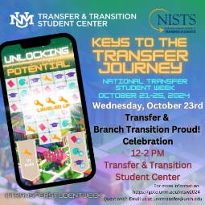Wednesday, October 23, 2024, from 12:00pm – 2:00pm.
Suggested caption: Today let’s celebrate you—with pizza and cake! UNM loves our Lobo Transfer and Lobo Branch Transition students, come celebrate being a transfer or branch transition student at UNM where you can meet fellow transfer and branch transition students. We have a special giveaway for all our transfer and branch transition students who attend! More information here: goto.unm.edu/ntsw2024 #transferstudentweek #iamalobo #transferproud

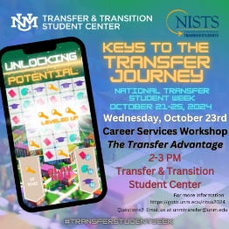Wednesday, October 23, 2024, from 2:00pm – 3:00pm.
Suggested caption: Calling all current UNM ABQ transfer and branch transition students to join us for pizza and a UNM Career Services presentation on how to leverage your transfer experience as a job seeker. Your experience has provided you with valuable skills to highlight! If you cannot attend in-person, go here to request a ZOOM link: https://goto.unm.edu/ntswcareersrvc

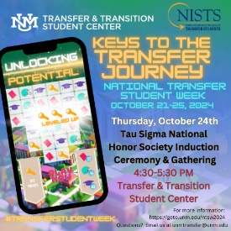Thursday, October 24, 2024 from 4:30 – 5:30 pm.
Suggested caption: UNM is the first institution in the state of New Mexico to start a chapter of the Tau Sigma National Honor Society, specifically recognizing high achieving transfer students. Today’s ceremony celebrates the great strides of our Tau Sigma students. For more information, contact us at unmtransfer@unm.edu
#transferstudentweek #iamalobo #transferproud

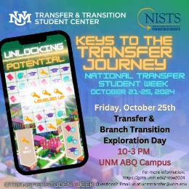Friday, October 25, 2024, from 10:00am - 3:00pm
Suggested caption: All future transfer and branch transition students who are interested in earning a bachelor’s degree from UNM Albuquerque are invited to attend this event! Don’t miss a day full of activities from presentations, campus connections fair, campus tours, lunch, and more! Full schedule, registration, and more information can be found here: goto.unm.edu/ntsw2024 #transferstudentweek #iamalobo #transferproud

