National Student Transfer Week at UNM
Social Media Guide

This is a posting guide for those who’d like to spread the word about the various events happening on UNM’s National Student Transfer Week 2022!

Please use the hashtags: #transferstudentweek #iamalobo #transferproud

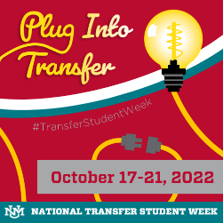
Save the date
Suggested caption: Celebrate UNM National Transfer Student Week! Check back for events throughout the week #transferstudentweek #iamalobo #transferproud

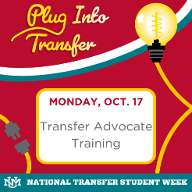
Suggested caption: To kick off UNM's National Transfer Student Week, attend a Transfer Advocate Training. Open to all UNM staff and faculty from any all UNM campuses, come learn best practices for supporting prospective and current transfer and transition students to the UNM Albuquerque Campus. Offered in both virtual and in-person formats. Virtual training will take place at 10 a.m., register here: https://goto.unm.edu/transferadvocate. In-person training will take place at 2 p.m. at Lobo A&B inside the SUB at the UNM ABQ Campus. Registration preferred, but not required. #transferstudentweek #iamalobo #transferproud

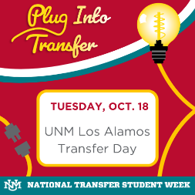
Suggested caption: UNM Los Alamos students get a chance to learn more about transferring to Main Campus. Visit here for more information: goto.unm.edu/ntsw
#transferstudentweek #iamalobo #transferproud

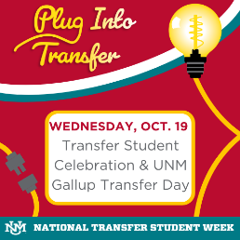
Suggested caption: Today let’s celebrate you—with cake! UNM loves our Lobo Transfer and Lobo Transition students, come celebrate being a transfer or transition student at UNM where you can meet fellow students who transferred from outside of UNM as well as students who transitioned to UNM Albuquerque from our various branch campuses. We have a special giveaway for all our transfer and transition students who attend! UNM Gallup is also celebrating their own transfer day! More information here: goto.unm.edu/ntsw #transferstudentweek #iamalobo #transferproud

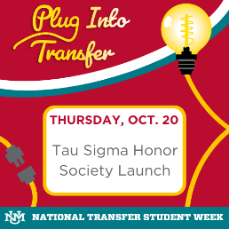
Suggested caption: UNM is the first institution in the state of New Mexico to start a chapter of the Tau Sigma National Honor Society, specifically recognizing high achieving transfer students. Today’s ceremony celebrates the induction of the chapter itself to UNM along with its very first members. For more information, contact Sarah E. Dominguez (skieltyk@unm.edu)#transferstudentweek #iamalobo #transferproud

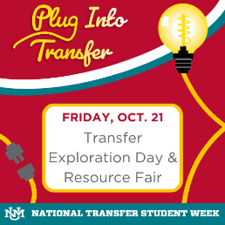
Suggested caption: All prospective students who are interested in transferring from another institution or transitioning from a different UNM campus to the UNM Albuquerque are invited to attend this event! Don’t miss a day full of activities from presentations, resource fair, campus tours, lunch, and more! Full detailed schedule, registration, and more information can be found here: goto.unm.edu/ntsw #transferstudentweek #iamalobo #transferproud

